**Name:=Purva Tagde PRN:=23070521111 SUB:=DBMS Lab**

**Extracting data using patterns**

Note: In sample code, change the table name and attributes according to your code.

# SQL LIKE Operator

The LIKE operator is used in a WHERE clause to search for a specified pattern in a column.

There are two wildcards often used in conjunction with the LIKE operator:

• The percent sign % represents zero, one, or multiple characters • The underscore sign _ represents one, single character

# Example

Select all customers that starts with the letter "a":

SELECT * FROM Customers

WHERE CustomerName LIKE 'a%';

Demo Database

|  |  |  |  |  |  |  |
| --- | --- | --- | --- | --- | --- | --- |
| **CustomerID** | **CustomerName** | **ContactName** | **Address** | **City** | **PostalCode** | **Country** |
| 1 | Alfreds  Futterkiste | Maria Anders | Obere Str. 57 | Berlin | 12209 | Germany |
| 2 | Ana Trujillo  Emparedados y helados | Ana Trujillo | Avda. de la  Constitución  2222 | México  D.F. | 05021 | Mexico |
| 3 | Antonio  Moreno  Taquería | Antonio  Moreno | Mataderos  2312 | México  D.F. | 05023 | Mexico |
| 4 | Around the  Horn | Thomas  Hardy | 120 Hanover Sq. | London | WA1 1DP | UK |
| 5 | Berglunds snabbköp | Christina  Berglund | Berguvsvägen  8 | Luleå | S-958 22 | Sweden |

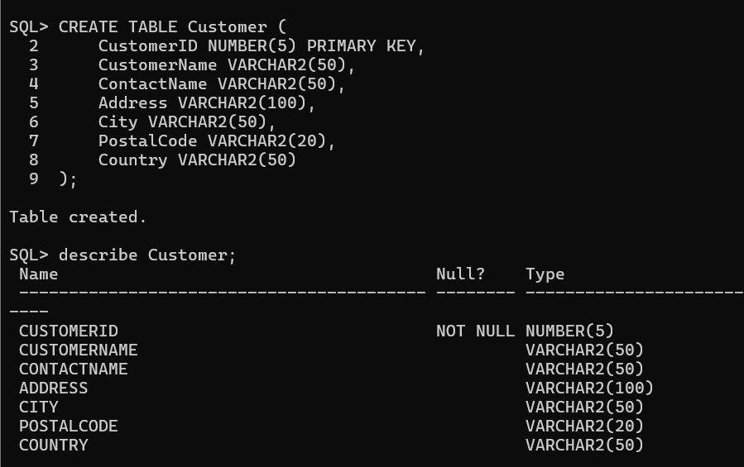

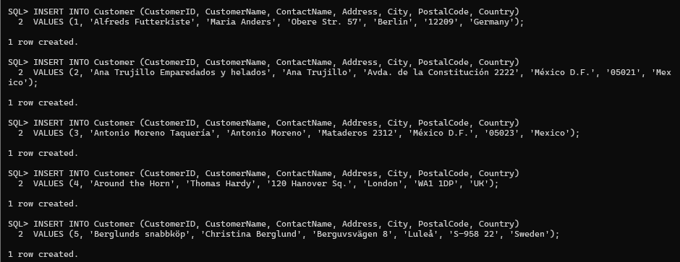

# The _ Wildcard

The _ wildcard represents a single character.

It can be any character or number, but each _ represents one, and only one, character.

# Example

Return all customers from a city that starts with 'L' followed by one wildcard character, then 'nd' and then two wildcard characters:

SELECT * FROM Customers

WHERE city LIKE 'L_nd__';

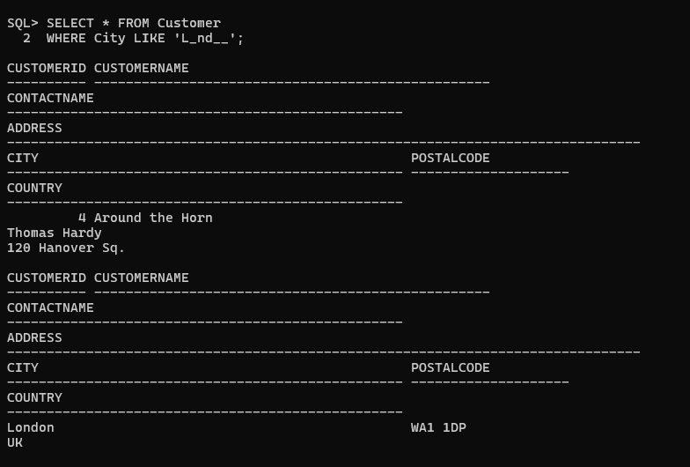

The % Wildcard

The % wildcard represents any number of characters, even zero characters.

# Example

Return all customers from a city that *contains* the letter 'L':

SELECT * FROM Customers

WHERE city LIKE '%L%';

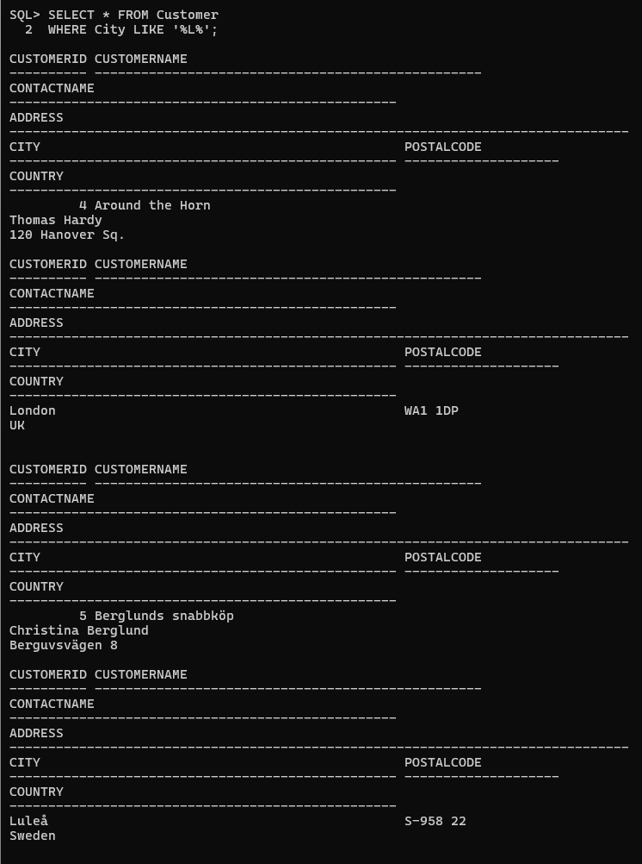

# Starts With

To return records that starts with a specific letter or phrase, add the % at the end of the letter or phrase.

# Example

Return all customers that starts with 'La':

SELECT * FROM Customers

WHERE CustomerName LIKE 'La%';



**Tip:** You can also combine any number of conditions using AND or OR operators.

# Example

Return all customers that starts with 'a' or starts with 'b':

SELECT * FROM Customers

WHERE CustomerName LIKE 'a%' OR CustomerName LIKE 'b%';

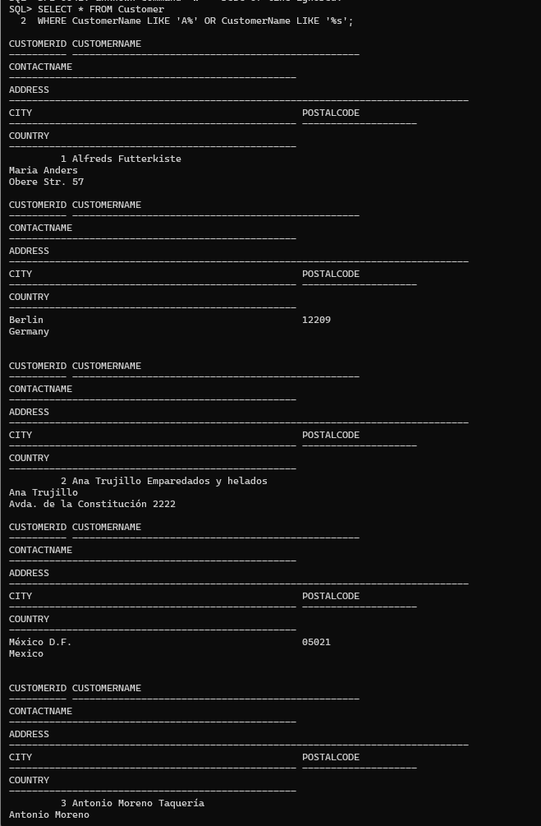

# Ends With

To return records that ends with a specific letter or phrase, add the % at the beginning of the letter or phrase.

# Example

Return all customers that ends with 'a':

SELECT * FROM Customers

WHERE CustomerName LIKE '%a';

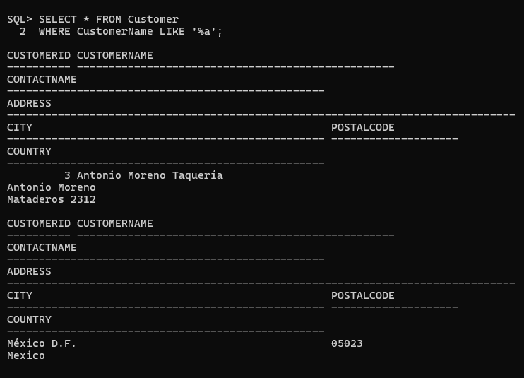

**Tip:** You can also combine "starts with" and "ends with":

# Example

Return all customers that starts with "b" and ends with "s":

SELECT * FROM Customers

WHERE CustomerName LIKE 'b%s';

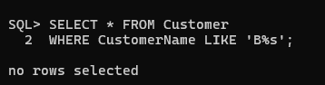

# Contains

To return records that contains a specific letter or phrase, add the % both before and after the letter or phrase.

# Example

Return all customers that contains the phrase 'or'

SELECT * FROM Customers

WHERE CustomerName LIKE '%or%';

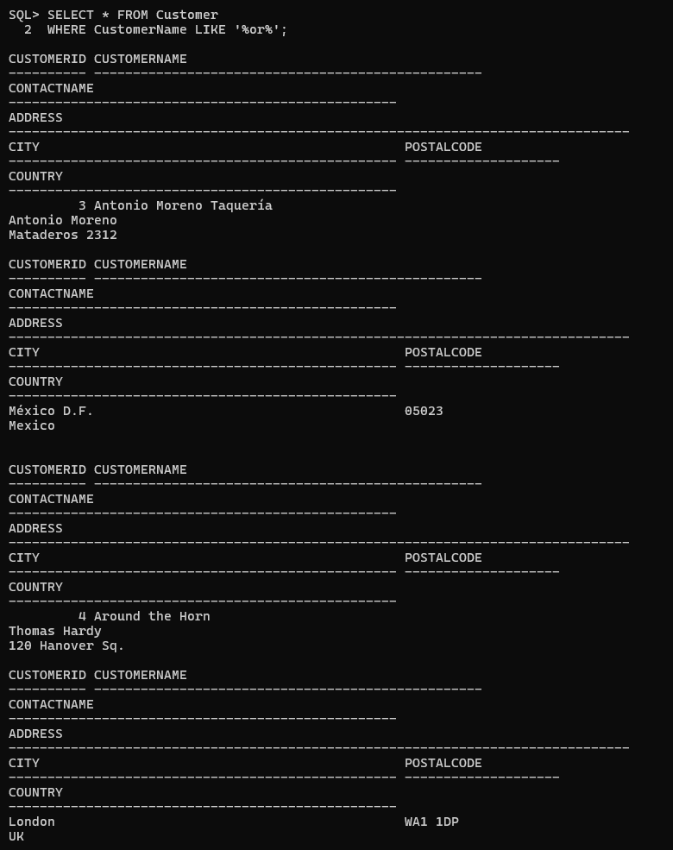

Combine Wildcards

Any wildcard, like % and _ , can be used in combination with other wildcards.

# Example

Return all customers that starts with "a" and are at least 3 characters in length:

SELECT * FROM Customers

WHERE CustomerName LIKE 'a__%';

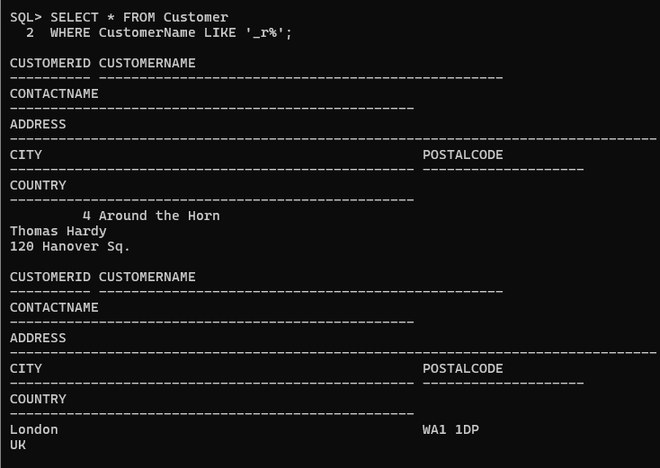

# Example

Return all customers that have "r" in the second position:

SELECT * FROM Customers

WHERE CustomerName LIKE '_r%';



Without Wildcard

If no wildcard is specified, the phrase has to have an exact match to return a result.

# Example

Return all customers from Spain:

SELECT * FROM Customers

WHERE Country LIKE 'Spain';

